**DAY 2:**

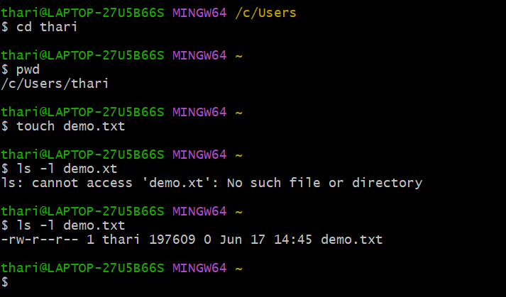

**Permissions:**

